# CONFERENCE MANAGEMENT SYSTEM

submitted in fulfillment of requirements for the award of the degree of

BACHELOR OF TECHNOLOGY

IN INFORMATION TECHNOLOGY

Submitted By

**Anugya Singh (21124014)**

**Mudit Rastogi**

**(21124069)**

**Jai Singh (21124061)**

**Jasmeen Kaur (21124045)**

Under the Mentorship of

**Dr. Neeraj Kumar**



**DEPARTMENT OF INFORMATION TECHNOLOGY**

**DR. B.R. AMBEDKAR NATIONAL INSTITUTE OF TECHNOLOGY JALANDHAR-144027, PUNJAB (INDIA)**

## November 12th, 2024

**Undertaking**

We declare that the project work presented in this report entitled **Conference Management System**, submitted to the Department of Information Technology, Dr. B R Ambedkar National Institute of Technology Jalandhar, for the award of the Bachelor of Technology degree in Information Technology, is our original work. We have not plagiarized or submitted the same work for the award of any other degree. In case this undertaking is found incorrect, we accept that our degree may be unconditionally withdrawn.

|  |  |
| --- | --- |
| Anugya Singh | 21124014 |
| Mudit Rastogi | 21124069 |
| Jai Singh | 21124061 |
| Jasmeen Kaur | 21124045 |

Department of Information Technology

Dr B R Ambedkar National Institute of Technology Jalandhar, Punjab, India

November 12th , 2024

**Certificate**

This is to certify that the project report entitled **Conference Management System** submitted by, **Anugya Singh (21124014), Mudit Rastogi (21124069), Jai Singh (21124065), Jasmeen Kaur (21124045)** to the Dr B R Ambedkar National Institute of Technology Jalandhar, in partial fulfillment for the award of the degree of B. Tech in Information Technology has been carried out under our supervision and that this work has not been submitted elsewhere for a degree.

### Dr. Neeraj Kumar

Assistant Professor

Department of Information Technology

Dr B R Ambedkar National Institute of Technology Jalandhar, Punjab, India

November 12th ,2024

**Acknowledgments**

We would like to acknowledge and give our most grateful and warmest thanks to our supervisor Dr. Neeraj Kumar for his continuous support and encouragement. His guidance and experience were a key factor in the success of the execution of the project.

We would like to thank the members of the team for the tons of sleepless nights they have put on this project.

Lastly we thank our classmates who helped us a lot in all the difficulties which we faced throughout the project.

We also thank all respondent who have given their value time, views and authentic information for this minor project. We thank each and everybody who has contributed directly or indirectly to the successful completion of this project.

# Table of Contents

|  |  |  |
| --- | --- | --- |
| **Sr. No.** | **Topic** | **Page No.** |
| 1 | **Introduction** |  |
| 1.1 | Introduction | 1 |
| 1.2 | Literature Review | 2 |
| 1.3 | Limitations of the system | 3 |
| 1.4 | Problem Statement | 3 |
| 1.5 | Hardware Specifications | 4 |
| 1.6 | Software Specifications | 4 |
| 1.7 | Objectives of the Project | 5 |
| 1.8 | Features of new System | 5 |
| 2 | **Software Requirement Specification** | 8 |
| 3 | **Design** | 9 |
| 4 | **Initial Features and Features** | 11 |
| 5 | **Authentication** | 13 |
| 6 | **Roles, Client profile and add conferences** | 15 |
| 7 | **Bibliography and References** | 17 |

**LIST OF TABLES**

|  |  |  |
| --- | --- | --- |
| Table No. | Table Name | Page No. |
| 1 | Hardware Specification | 4 |
| 2 | Software Specification | 4 |

**LIST OF FIGURES**

|  |  |  |
| --- | --- | --- |
| Figure No. | Figure Name | Page No. |
| 1 | Use Case diagram overview | 09 |
| 2 | Interface design diagram overview | 10 |
| 3 | Initial Features and Features | 11 |
| 4 | Authentication | 13 |
| 5 | Roles, Client profile and add conferences | 15 |

1. **INTRODUCTION**

### Introduction

Online management system is very important nowadays in education, recently many systems have been designed in this field to help the users to communicate online.

**The Conference Management Online System** is the system that will be used by Event Manager in order to manage conference papers that were submitted by the authors, examples of these systems are shown in [5], [6]. In this study, the implementation of system features would provide an efficient submission of conference papers that will be arranged systematically which will be easier for users to understand.

The main objective of this system is to give IIUM a specific platform for them to organize their own conference with their own system. It would assist the Event Manager in organizing the conference papers that are submitted by the authors which would be reviewed in a professional, efficient and systematic way. This system would also alert authors about new information of upcoming conference that will be held and it would provide brief information about the event. In addition, the authors of each paper would be encouraged to participate in conferences as this would give an opportunity to knowledgeable authors to share their conference papers.

### Literature Review

This chapter would be reviewing few existing conference management online systems that were used by other organizations and it would be compared with the new system. This would allow the organization (IIUM) to know what they lack in their current business management and try to find ways to improve their management system for better performance as well as to follow the evolution and growth of technology that can change from time to time.

### EXISTING SYSTEMS

* + 1. **EasyChair Conference System**

EasyChair is a free conference management system that is flexible, easy to use, and has many features to make it suitable for various conference models. The first version of EasyChair was implemented in 2002 and it was used by 12 conferences in 2002–2004 and by 66 conferences in 2005. Besides that, it is currently the most commonly used for conference management system. This conference management system aims at helping conference organizers at all stages and facilitates the creation of conference as well as the workshop proceedings [1].

### OpenConf Conference 2012

OpenConf Conference 2012 is an abstract and peer-review management system that facilitates the submission and review processes for conferences and workshops. This system was developed using PHP language together with MySQL database and available for installation on the client server.

This management system is available in two editions which is Community and Professional. For the Community edition, it provides a peer-review system that is suitable for many organizations and it is free but with limitation support they offer. On the other hand, Professional edition includes all the Community edition, technical support, additional features and available with multiple deployment options [2].

### iChair

iChair is a powerful submission/review server software which is designed to help the program chair or event manager of a conference with the submission and collection of articles, assignment of articles to reviewers, review collection of submitted articles, discussions among reviewers, and mailing to authors and reviewers.

This online management system was developed with a view to being as easy to install as possible. It was developed in PHP5 and intended to run on an apache web server. As this would allow easy installation on a Linux box which it should be possible by anyone (even with only basic knowledge of server administration) in about one or two hours. It might even be possible to run it on a windows based server (but this was never tested) [3].

### Limitations of the System

There is no available conference Event Manager that would test the Conference Management Online System that was developed due to it being time consuming which makes it hard to actually know all of the weakness of the system. For the system constraint, some problem was faced regarding the coding for the system to be functioning because more understanding is needed in developing the system and it would be difficult to get all the information because of the information sensitivity of the existing system in IIUM.

### Problem Statement

An online conference management system facilitates the seamless organization and execution of virtual conferences, addressing various logistical and administrative challenges. At its core, the system provides robust functionalities for conference scheduling, attendee registration, and session management. Users, including conference organizers and participants, can access the platform to create events, define agendas, and manage attendee registrations efficiently. Key features typically include a user-friendly interface for event creation and customization, integration with payment gateways for handling registration fees, and automated email notifications to keep attendees informed about schedules and updates. Additionally, the system supports virtual session management, enabling hosts to schedule and conduct live or pre-recorded presentations, panel discussions, and workshops. It also incorporates interactive tools like Q&A sessions, polls, and chat functionalities to enhance participant engagement and networking opportunities.

Overall, the online conference management system aims to streamline the entire conference lifecycle, from planning and registration to live event execution and post- conference analytics, ensuring a smooth and engaging experience for organizers and attendees alike.

.

### Hardware Specifications

|  |  |
| --- | --- |
| HARDWARE SPECIFICATION | |
| Client Side | |
| RAM | 512 MB |
| GPUs | NVIDIA GPUs |
| Processor(CPU) | 800 MHz Intel Core Duo or Higher or Ryzen |
| Server Side | |
| RAM | 2GB or Higher |

*Table 1: Hardware Specification*

### Software Specifications

|  |  |
| --- | --- |
| SOFTWARE SPECIFICATION | |
| Client Side | |
| Operating System | Windows 7 and above |
| Web Browser | Google Chrome or any other upto  date Browser |
| Server Side | |
| Operating System | Windows 7 and above |
| Web Technology: |  |
| Front-end: | CSS,Javascript,HTML,BOOTSTRAP |
| Back-end | NodeJs |
| Database | MongoDB |

*Table 2: Software specification*

### Objectives of the Project

* **Streamline Event Organization**: Facilitate the management of all conference- related tasks, from scheduling to speaker coordination, in a single platform.
* **Simplify Registration and Ticketing**: Provide an easy-to-use system for attendees to register, pay, and access conference materials.
* **Enhance Communication**: Enable seamless communication between organizers, speakers, and attendees through notifications, reminders, and messaging systems.
* **Increase Accessibility and Participation**: Allow attendees from around the world to participate remotely, increasing the reach and inclusivity of the event.
* **Provide Data and Analytics**: Collect feedback and provide analytics on attendee participation, preferences, and event performance for future improvements.

### Features of new System

In the Conference Management Online System, there is a need for future enhancement in order for the system to be user friendly. This is important because it will influence the effectiveness of certain part of the system for example the Conference Management Online System does not have an edit function for any function in the system. Adding the edit function will give a feel of user friendly as this would allow the user to be able to edit any information about him and the conference. Other areas that need to be given attention are:

* Profile page (Author, Reviewer, Event Manager)
* Call for papers
* Important dates

## Software Requirement Specification

### Introduction

* 1. **Purpose**

The purpose of this document is to outline the software requirements for the development of an Online Conference Management System (OCMS). This system will automate the process of organizing, managing, and attending online conferences.

### Scope

The OCMS will allow organizers to create, manage, and schedule conferences, while allowing attendees to register and participate. The system will also provide features for communication, ticketing, and feedback collection. The project will be implemented as a web application accessible to users globally.

* 1. **Definitions, Acronyms, and Abbreviations OCMS**: Online Conference Management System **SRS**: Software Requirements Specification **Attendee**: Person attending the conference **Organizer**: Administrator organizing the conference

### Overall Description

* 1. **Product Perspective**

The OCMS will be a standalone web application with a user-friendly interface, providing functionalities for conference organizers and attendees. It will leverage cloud hosting for scalability and reliability.

### Product Features

* + - User Registration & Login
    - Conference Creation and Scheduling
    - Attendee Registration and Ticketing
    - Communication and Notification Features
    - Post-conference Feedback and Analytics

### User Classes and Characteristics

**Administrator/Organizer**: Users responsible for organizing and managing the conferences.

**Attendee**: Users attending the conferences.

### Operating Environment

The system will be accessible via web browsers and optimized for mobile and desktop platforms. It will use modern web technologies (HTML5, CSS, JavaScript) and server-side technologies (Node.js).

### Design and Implementation Constraints

* The system must support multiple concurrent users.
* Should comply with GDPR and other data protection regulations.

### Assumptions and Dependencies

* Users will have access to a stable internet connection.
* External services like payment gateways may be used for ticketing.

### Functional Requirements

* 1. **User Management Module**

The system shall allow users to register, login, and recover lost passwords. The system shall allow different roles: Administrator/Organizer and Attendee. Administrators shall be able to view and manage user information.

### Conference Scheduling and Management Module

The system shall allow organizers to create, edit, and delete conference events. Organizers shall be able to set schedules, assign speakers, and upload session materials. The system shall generate unique conference links for virtual sessions.

### Registration and Ticketing Module

The system shall allow attendees to register for a conference by filling out a registration form. The system shall allow attendees to purchase tickets using a payment gateway.

The system shall issue electronic tickets or receipts for confirmed registrations.

### Communication and Notification Module

The system shall send automated email confirmations for registrations and payments.

The system shall send reminders and updates to attendees before and during the conference. The system shall allow organizers to broadcast announcements to all registered attendees.

### Feedback and Analytics Module

The system shall allow attendees to submit post-conference feedback through forms or surveys.

The system shall generate analytics reports based on attendance, ticket sales, and feedback.

### Non-Functional Requirements

* 1. **Performance Requirements**

The system shall support up to 1,000 concurrent users without significant performance degradation.

Response times for user actions should not exceed 3 seconds under normal load.

### Security Requirements

The system shall use encryption (SSL/TLS) for all sensitive data transmissions.

User data, especially payment information, shall be securely stored and comply with data protection laws (e.g., GDPR).

### Usability Requirements

The system shall have a responsive design, providing a consistent experience on both mobile and desktop devices.

The user interface shall be intuitive and easy to navigate, requiring minimal training.

### Reliability Requirements

The system shall have an uptime of 99.5% during conference events.

In case of system failure, it shall be able to recover within 10 minutes using backup systems.

### Scalability Requirements

The system shall be scalable to accommodate an increase in users and events without performance issues.

### Maintainability Requirements

The system shall be modular, making it easy to update individual components without affecting the entire system.

### Other Requirements

**Backup and Recovery**: Regular backups shall be taken, especially during high-traffic conference periods.

**Compliance**: The system must adhere to international standards for accessibility (e.g., WCAG) and data protection (e.g., GDPR, HIPAA).

### 5. Glossary

* **Administrator**: A user with full control over the system who manages conferences, users, and settings within the platform.
* **API (Application Programming Interface)**: A set of protocols that allow different software components to communicate with each other.
* **SSL/TLS (Secure Sockets Layer / Transport Layer Security)**: Encryption protocols used to secure data transmitted between the user’s browser and the server, protecting sensitive information like login credentials and payment data.
* **WCAG (Web Content Accessibility Guidelines)**: A set of guidelines designed to ensure web content is accessible to all users, including those with disabilities.
* **SRS**: Software Requirements Specification
* **GDPR**: General Data Protection Regulation

1. **DESIGN**

### Use Case Diagram

Use case diagrams model behavior within a system and helps the developers understand of what the user require. The stick man represents what’s called an actor. Use case diagram consists of use cases and actors and shows the interaction between the use case and actors.

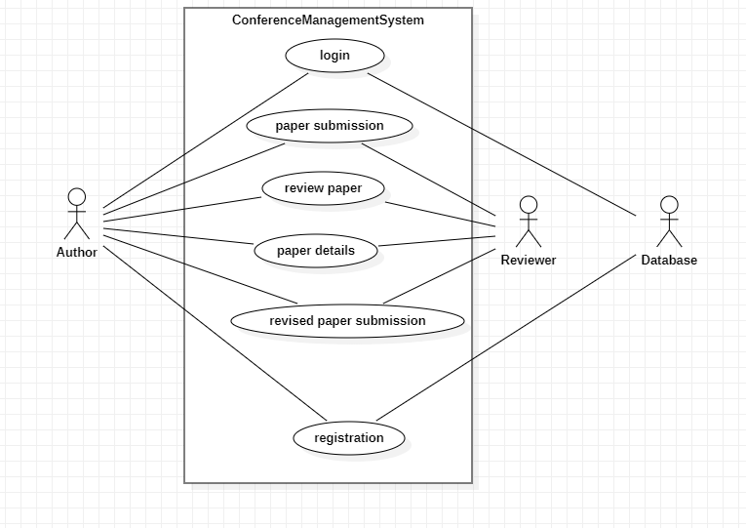

*Figure 3.1 Use case Diagram Overview*

### Interface Design Diagram

An interface design diagram visually represents how users interact with a system, outlining the structure, flow, and layout of the user interface (UI). It illustrates the key components such as buttons, menus, forms, and links, along with the relationships between them. The diagram helps designers and developers understand how different screens or pages are connected and how users will navigate through the system. It also shows the interaction flow between user actions and system responses.

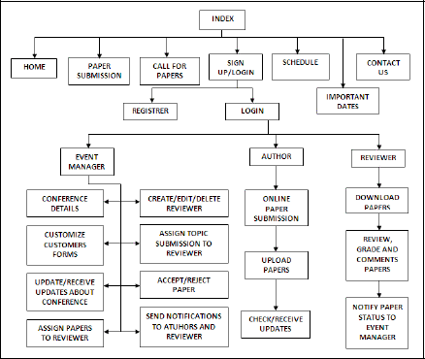

*Figure 3.2 Interface design diagram overview*

## Initial pages and Features

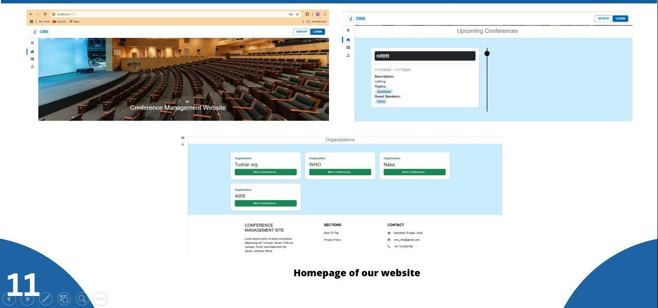

*Figure 4.1. initial pages and features*

The image consists of three main sections, illustrating key components of the homepage for a Conference Management Website, which serves as a platform to manage and explore various conferences organized by different entities. These sections provide a comprehensive overview of the website’s user interface, functionalities, and design elements aimed at enhancing user experience.

The top-left section is dominated by a wide banner that visually represents a conference setting, with a photo of a large auditorium filled with rows of empty chairs facing a stage and presentation screen. This imagery reinforces the theme of conference management, immediately orienting the user to the website’s purpose. Above the banner, we see the site's branding in the form of "CMS" (Conference Management Site) displayed prominently on the left side of the header. On the right side of the header are "Sign Up" and "Login" buttons, which provide easy access for new users to register and for returning users to log into their accounts. This header structure is streamlined to prioritize accessibility, allowing users to quickly navigate the site. The banner itself also includes dynamic text that reads "Conference Management Website," which likely rotates or scrolls to attract user attention, adding a touch of interactivity to the homepage.

The top-right section showcases the “Upcoming Conferences” area, where individual conferences are displayed in a card-like layout. Each card is neatly organized and provides

essential information about a specific conference, such as the conference title, date, and a brief description. Additional details include the topics covered and guest speakers, with an example shown for a conference named "nittttt," which is scheduled to occur from 11/15/2024 to 11/17/2024. Although this particular conference description reads "nothing," it's likely a placeholder that can be customized. The topics listed for this conference include "database," and a guest speaker named "Hima" is mentioned, adding a personal touch that may help attract potential attendees. This organized, card-based display allows users to efficiently browse through multiple conferences and select events of interest. A scrollbar on the right side of the section suggests that the list can accommodate a large number of conferences, enhancing the site’s ability to present a variety of upcoming events without overwhelming the user.

The bottom section of the image focuses on the “Organizations” area, which highlights various entities responsible for hosting conferences on the platform. Here, each organization is represented by a rectangular card with the organization’s name displayed prominently at the top. Examples include well-known organizations like “WHO” and “NASA,” as well as “Tushar org” and “AWS.” Each organization card has a “More Conferences…” button, which implies that clicking it would lead users to a dedicated page listing all conferences hosted by the respective organization. This feature allows users interested in events by specific organizations to easily find and explore them, fostering a sense of connection with trusted hosts. The blue background of this section complements the overall color scheme and enhances readability.

At the bottom of the “Organizations” section, there is a footer area that provides quick access to essential information and resources. This section includes a brief description titled “CONFERENCE MANAGEMENT SITE” alongside placeholder text that resembles “Lorem ipsum,” indicating where a detailed site description could be added in the future. Additionally, the footer includes links to sections like "Back to Top" and "Privacy Policy," offering quick navigation and ensuring users can easily return to the top of the page or access the site’s privacy terms. To the right, contact details such as an address, email (e.g., [cms_help@gmail.com),](mailto:cms_help@gmail.com) and phone number (+91 123456789) are provided, making it easy for users to get in touch with the site’s administrators for support or inquiries. These details help establish trust and credibility by providing real-world contact information.

Overall, these three sections collectively showcase a well-organized, user-friendly homepage that highlights the website’s core functionalities, including browsing conferences, exploring organizations, and providing easy access to support.

## Authentication

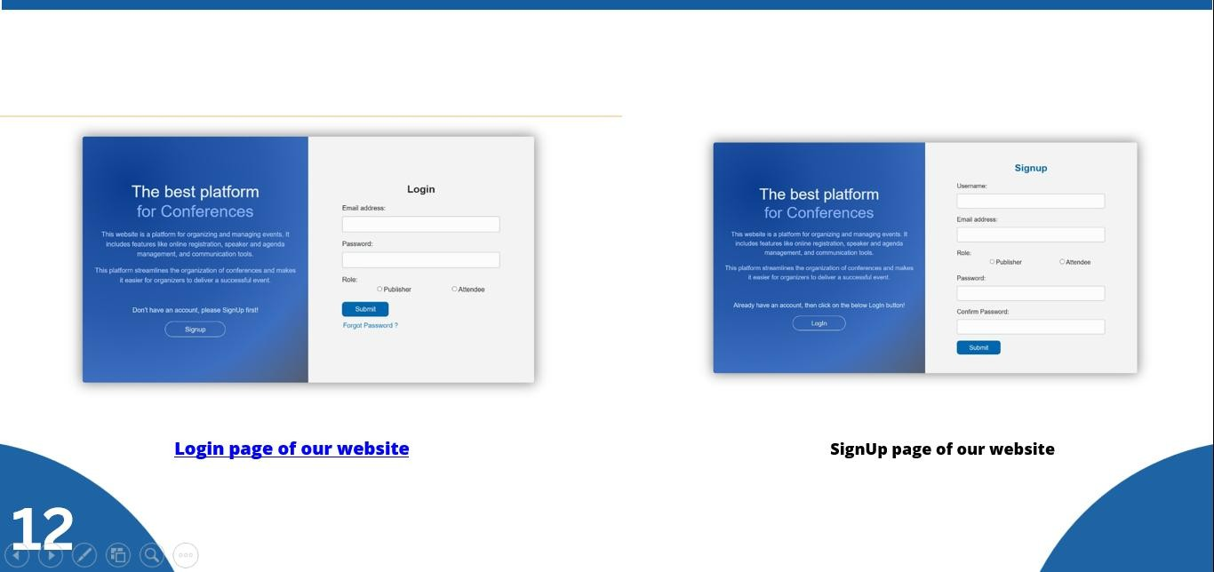

*Figure 5.1 Authentication*

The image showcases two main components of the Conference Management Website: the login and signup pages, which are critical for user authentication and access control. These interfaces are essential for differentiating between users and providing appropriate access levels based on user roles, such as "Publisher" or "Attendee."

The left section displays the login page. This page is designed with a split interface, where the left side contains a promotional message against a blue gradient background, highlighting the website's purpose as "The best platform for Conferences." This message informs users that the platform provides features like online registration, speaker and agenda management, and communication tools, all of which are aimed at simplifying conference organization and enhancing the event experience. The message also includes a call to action: "Don't have an account, please SignUp first!" beneath which there is a "Signup" button. This section not only reinforces the platform's purpose but also guides new users who might need to create an account before logging in. On the right side of the login page, users are prompted to enter their credentials in a minimalist form. The form fields include "Email address" and "Password," along with a "Role" selection option, where users can choose between "Publisher" and "Attendee" roles. This role selection helps the platform tailor user experiences based on whether they are organizing events or attending them. At the bottom of the form, there are "Submit" and "Forgot Password?" links, providing convenient options for form submission or account recovery, respectively.

The right section of the image displays the signup page, which follows a similar split-design pattern. The left side again contains the promotional message, emphasizing the platform’s value and target audience, but with a subtle difference in text. Here, it reads, "Already have an account, then click on the below Login button!" accompanied by a "Login" button, which redirects existing users to the login page. This guidance effectively minimizes confusion for returning users who might have navigated to the signup page by mistake. On the right side of the signup page is a registration form, which is slightly more detailed than the login form, as it requires additional information from new users. The fields include "Username," "Email address," "Role," "Password," and "Confirm Password." The "Role" selection (with "Publisher" or "Attendee" options) ensures that the platform records user type at the time of registration, allowing for personalized access and features. The "Password" and "Confirm Password" fields add a layer of security, ensuring that users enter their passwords correctly. Once the form is completed, users can click the "Submit" button to create their account.

Both pages are designed with a user-friendly interface that simplifies the process of logging in and signing up, while the consistent blue gradient background gives a professional and cohesive look across the site. This design ensures that the login and signup processes are straightforward and accessible, with clear distinctions for new and existing users, making it easy for users to navigate the authentication process and get started with managing or attending conferences. The overall layout and design of these pages reflect a well-organized approach to user experience, prioritizing clarity and ease of use in accessing the platform’s main functionalities.

## Roles, Client Profile and add conferences

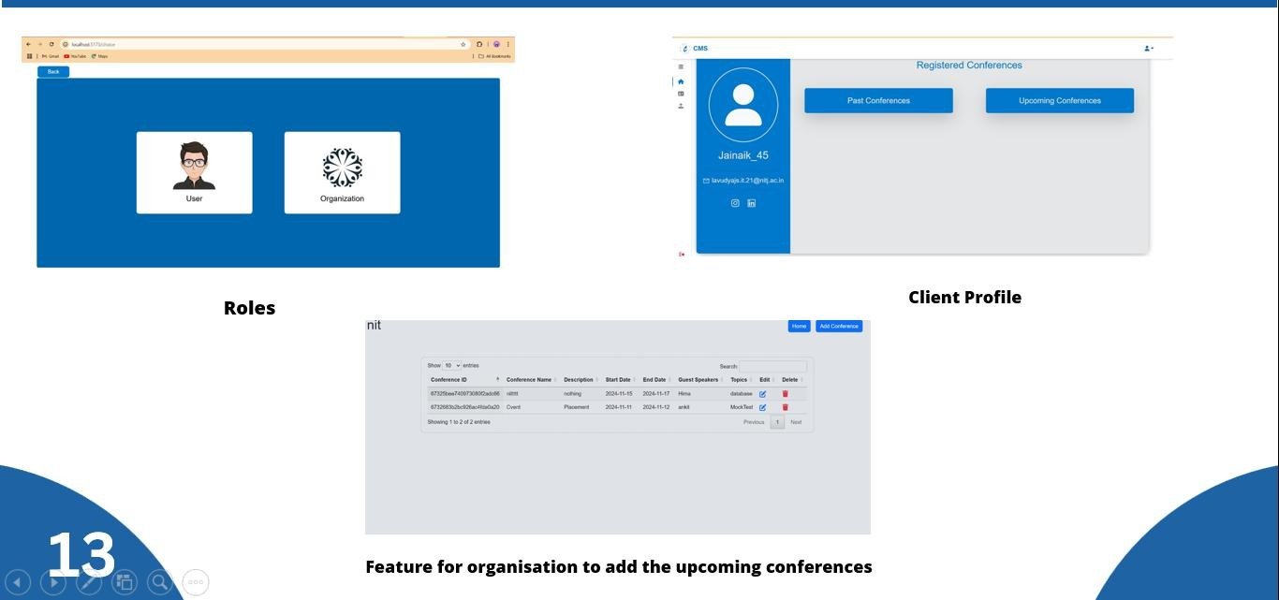

*Figure 6.1 Roles, Client profiles and add conferences*

This image illustrates three different sections of the Conference Management Website: the role selection screen, the client profile page, and the feature for organizations to add upcoming conferences. Each section highlights a unique functionality of the platform, focusing on user roles, personalized profiles, and administrative tools for conference management.

The first section, titled "Roles," presents the role selection screen where users can choose their type of account: "User" or "Organization." The interface is simple and user-friendly, featuring two large icons against a blue background. The icon on the left, depicting a person, represents the "User" role, likely aimed at general attendees who wish to browse or register for conferences. On the right, an icon resembling a logo represents the "Organization" role, designated for entities that organize conferences. This initial role selection screen is crucial as it helps the platform distinguish between regular users and conference organizers, enabling it to tailor the experience according to each user type’s needs. By separating these roles from the beginning, the platform can provide customized functionalities, such as allowing organizations to manage conferences and users to view or register for events.

The second section, labeled "Client Profile," displays an example profile page for a registered user. The profile interface is streamlined, with a clean and professional look, providing easy access to relevant information. In this example, the user’s profile information includes a profile picture placeholder, username (e.g., "Jainaik_45"), and email address (e.g.,

[tsavadi.jain.21@jmi.ac.in).](mailto:tsavadi.jain.21@jmi.ac.in) The profile page also includes quick links to the user's social media accounts, suggesting a focus on networking, which is a key feature for conference participants. On the right side of the profile page, there are two prominent buttons labeled "Past Conferences" and "Upcoming Conferences." These buttons allow users to quickly navigate between their previously attended events and those they have registered for in the future. This layout prioritizes ease of navigation, helping users efficiently manage their conference schedules and providing a seamless experience as they engage with the platform.

The third section, titled "Feature for Organization to Add Upcoming Conferences," showcases an interface designed specifically for organizations to manage and add new conferences. This administrative feature includes a table that lists conferences currently scheduled or managed by the organization. The table columns provide detailed information, including "Conference ID," "Conference Name," "Description," "Start Date," "End Date," "Guest Speakers," and "Topics," along with options to edit or delete each entry. In the example shown, two conferences are listed: one titled "Placement," scheduled from 11/11/2024 to 11/12/2024, with "Arpit" as a guest speaker on the topic "Mock Test," and another titled "nittttt," scheduled from 11/15/2024 to 11/17/2024, featuring "Hima" as a speaker on the topic "database." This structured layout makes it easy for organizations to keep track of their events and manage them effectively. Additionally, there is an "Add Conference" button, which likely opens a form for adding new events to the list, allowing organizations to efficiently manage their conference schedules and make updates as needed.

Overall, these three sections work together to provide a comprehensive user experience tailored to the needs of both attendees and organizers. The role selection screen sets the foundation for a personalized experience, the client profile page supports attendee engagement with past and upcoming events, and the organization management feature streamlines the process of scheduling and modifying conferences. The design is consistent across all sections, using blue and gray tones to convey a professional and modern aesthetic while ensuring readability and ease of navigation. This cohesive design approach enhances usability and positions the Conference Management Website as a practical and organized platform for both users and organizations involved in the event industry.

1. **BIBLIOGRAPHY AND REFERENCES**

### COMS:

Conference Management Toolkit, "COMS," *Conference-Service.com*. [Online]. Available: <https://conference-service.com/>.

### SpaCy:

Explosion AI, "SpaCy: Industrial-Strength Natural Language Processing in Python,"

*SpaCy.io*. [Online]. Available: <https://spacy.io/>.

### PyTorch:

Meta AI, "PyTorch," *PyTorch.org*. [Online]. Available: <https://pytorch.org/>.

### EasyChair:

EasyChair Conference System, "EasyChair: The conference management system,"

*EasyChair.org*. [Online]. Available: <https://easychair.org/>. [1]

### Unsplash:

Unsplash, "Free high-resolution photos," *Unsplash.com*. [Online]. Available: <https://unsplash.com/>. [2]

### ICHAIR:

NIMR, "ICHAIR: International Conference on Health, Immunity, and Research,"

*NIMR.gov.ng*. [Online]. Available: <https://nimr.gov.ng/ichair/>. [3]

### OpenConference2012::

OpenConf, "Open Conference Systems," *OpenConf.com*. [Online]. Available: <https://www.openconf.com/portfolio/>. [4]